This report presents a comprehensive statistical analysis of morphometric measurements from 200 crabs of the species Leptograpsus variegatus. The dataset, obtained from the MASS package in R, contains measurements on two species (blue and orange) and both sexes (male and female), with five key morphological variables: frontal lobe size (FL), rear width (RW), carapace length (CL), carapace width (CW), and body depth (BD)
The dataset consists of 200 observations with 8 variables. The key grouping variables are species (sp) with levels "B" (blue) and "O" (orange), and sex with levels "F" (female) and "M" (male). The morphometric measurements are all recorded in millimeters.

Each of the four groups (Blue females, Blue males, Orange females, Orange males) contains exactly 50 crabs, representing 25% of the total sample. This perfect balance is a significant advantage for statistical analysis, as it eliminates concerns about unequal group sizes when making comparisons between species and sexes.
SPECIES | FEMALE | MALE
BLUE | 50 | 50
ORANGE | 50 | 50

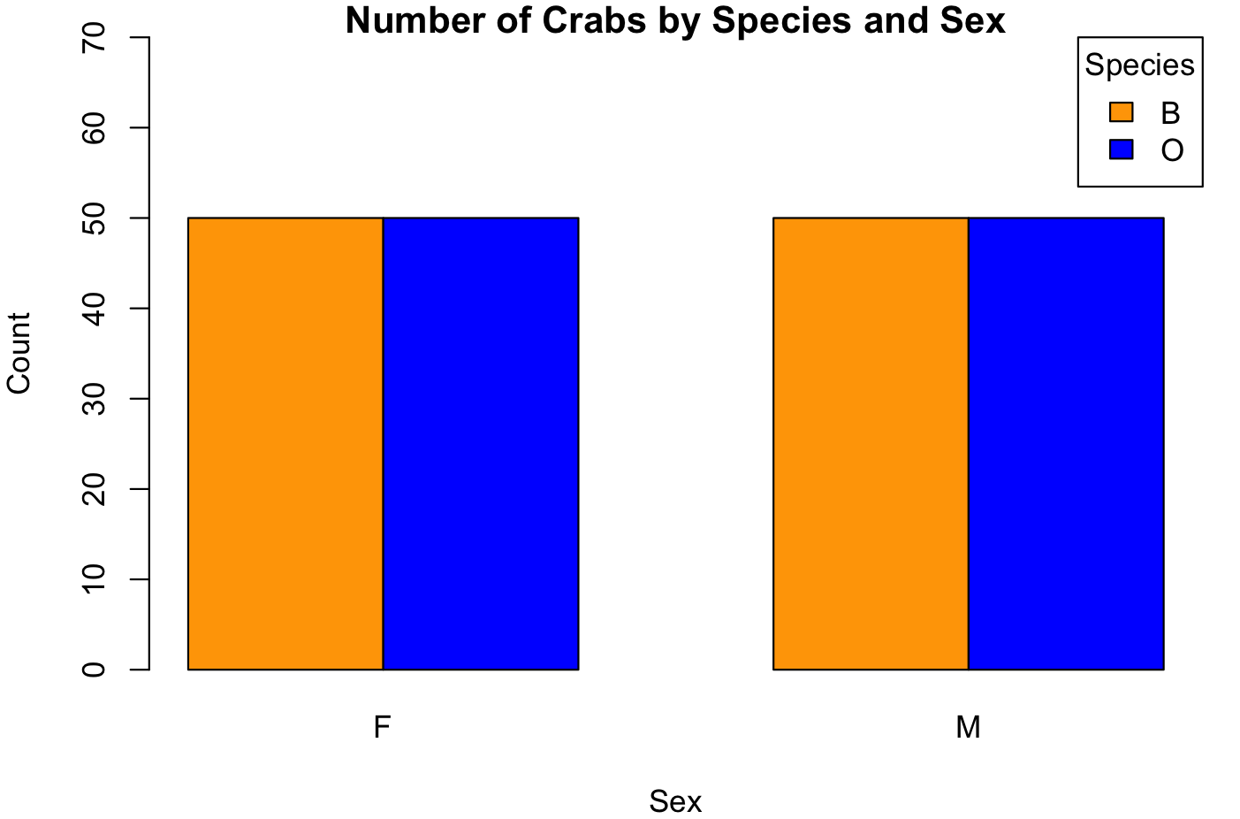
The bar chat above summarizes the group compostions which also confirms that each of the four groups contain exactly 50 crabs which makes the dataset balanced.

Boxplot analysis of body depth reveals clear patterns of variation among the four groups. The fiqure below shows the side-by-side boxplots that visually demonstrate the differences between groups.
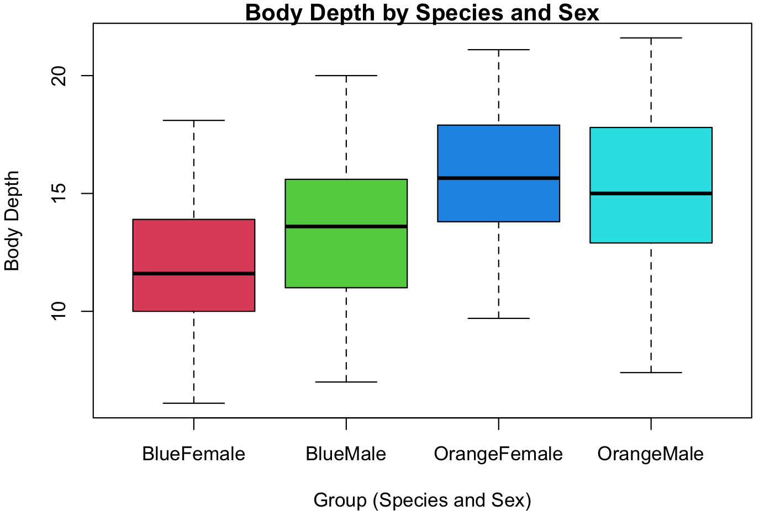

From the diagram above, we can see that there are no outliers meaning that all the data points in your dataset fall within a specific, expected range of variability.

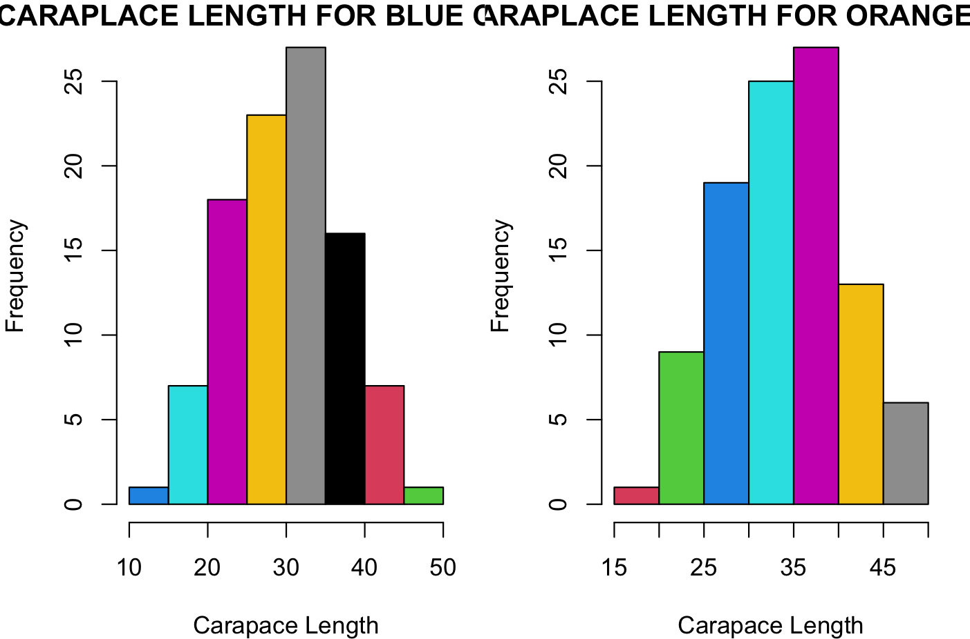
From the diagram above, the mean of caraplace length for blue crabsis 30.06 and the median is 30.10,since the median>mean it is right skewed.It is also unimidal since it has one peak. Also, For orange carbs, the mean of caraplace length is 31.28 and the median 34.55. The median is greater than the mean, which suggests that the distribution of carapace lengths for orange crabs is right-skewed. Additionally, the histogram for orange crabs shows a single peak, indicating that the distribution is unimodal.
The means of each morphological measurement is given in the tab le below
GROUPS | FL | RW | CL | CW | BD
BF | 13.270 | 12.1 | 28.1 | 32.6 | 11.8
BM | 14.842 | 11.7 | 32.4 | 36.8 | 13.3
OF | 17.5 | 14.8 | 34.6 | 39.0 | 15.6
OM | 16.6 | 12.2 | 33.6 | 37.1 | 15.3

